Department of Computer Science and Engineering
The University of Texas at Arlington
Sliding Profiler
Architecture Design Specification

Super Duper TxDOT Troopers

Team Members:
Tim Dockins
Robyn Johnson
Brandon Skinner
Late Updated: d MMMM yyyy 39986.7652777778 h:mm:ss am/pm
Copy Printed: d MMMM yyyy 39982.4569444444 h:mm:ss am/pm

Table of Contents
1 Introduction 1
1.1 Overview 1
1.2 Product Scope and Overview 1
1.3 Document Organization 1
1.4 Definitions 2
2 Systems Overview 3
2.1 Software Deployment 3
2.2 Systems Motivation 3
2.3 External Interface 4
2.4 Inter-system Interfaces 4
3 Platform System 5
3.1 General 5
3.2 Subsystems 5
3.3 Inter-subsystem Connections 6
4 Hardware System 7
4.2 Subsystems 7
4.3 Inter-subsystem Dataflow 9
5 Software System 11
5.1 General 11
5.2 Architectural Composition / Deployment 11
5.3 Layers and Subsystems Definitions 12
5.4 Inter-subsystem Dataflow 18
6 Testing Considerations 23
6.1 General 23
6.2 Physical / Structural 23
6.3 System-level Connectivity Requirements 23
6.4 Subsystem-level Interfaces 23

Introduction

Overview
This document specifies the architectural design for the Sliding Profiler. The general approach used is an interrelated systems model defining the each system as a set of subsystems where each subsystem provides the functional relationships between the systems. The motivation here is to enable an abstraction in the detailed design process between the systems so that changes in one system require little to no change in other systems.

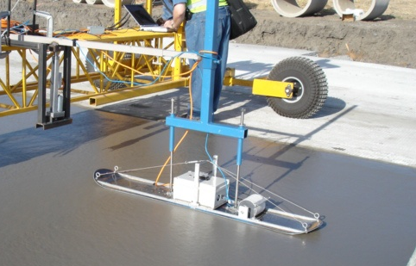
Product Scope and Overview
The Sliding Profiler is currently realized as a prototype used by TxDOT contractors . It is designed to slide behind a road paving machine to measure and indicate sharp bumps in the pavement that would cause poor ride quality.
The scope of this effort is to replace and redesign the key components of this product. These components are as follows:
Figure 1 - Existing Sliding Profiler
- Platform – Currently implemented as a snow ski
- Embedded Device – currently an embedded PC running Windows CE
- Client Software – Not implemented with the current prototype
In terms of this architecture, this effort replaces the three components as the three systems described below.

Document Organization
The document is organized as follows:
Section 1 Introduction, Product Scope and Definitions
Section 2 Systems Overview, Deployment
Section 3 Platform System
Section 4 Hardware System
Section 5 Software System
Sections 3, 4 and 5 describing the three systems are further divided into first describing their subsystems, then indicating the connectivity and dataflow between them. This is to provide the reader with a basic understanding of the purpose behind each subsystem.

Definitions
- Operational Data data indicating bump and/or exception events
- Raw Data sensor information received directly from the sensors
- Paver a machine used to mold cement into lane-width pavement
- TxDOT Texas Department of Transportation

Systems Overview
The Sliding Profiler may be decomposed into three distinct, but interrelated systems; platform, hardware and software. While each system can be described separately, they must rely on each other to perform the overall function of the device. This document provides the architectural makeup of the product with relation to those systems.
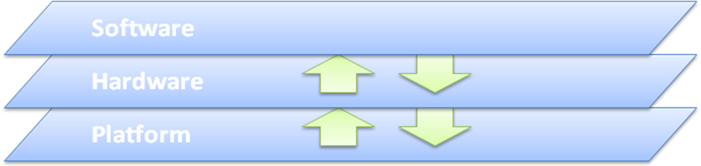
Figure 2 - Sliding Profiler Systems

Software Deployment
The Software system is deployed across two operating systems:
- A client PC
- An embedded device
Software subsystems may be discussed in terms of their deployment as client software and embedded software.

Systems Motivation
This systems arrangement is motivated by several factors:
- Clear construction delineation with well-understood interfaces
- Black-box testing considerations
- Highlights the coupling between systems
Given these considerations, special care will be given to the Software/Hardware coupling. As the Hardware system is an embedded system, the implementations of those two systems are highly interdependent. Further, this interdependency encroaches on the design efforts. Therefore, special consideration and forethought must be given to designing and implementing these systems.

External Interface
The primary external interface to the product is through the Platform system. This is in terms of physical contact with the cement. This is translated through the Sled subsystem of the Platform to the sensor subsystems of the Hardware.

Inter-system Interfaces
In general, dataflow between systems is in terms of physical forces or electrical impulses.

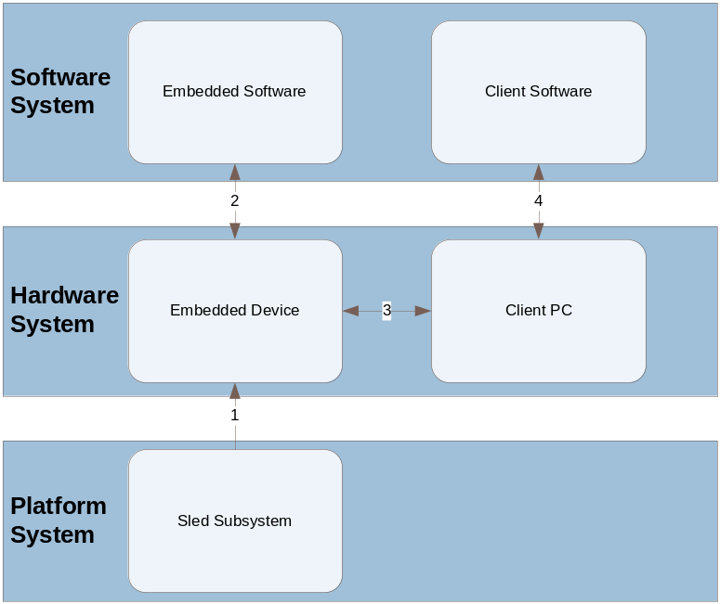
Figure 3 - Inter-System Interfaces

Inter-system Connectivity

Connection | Description
1 | Physical translation of forces by the Sled subsystem to the embedded device
2 | Translation of a voltage signal from the embedded device to something readable by the embedded software
3 | Communication signal or otherwise transference of data from the embedded device to the client PC. This is data from and commands to the embedded device.
4 | Provision of data from the embedded device to the client software through the client PC.
Table 1 - Inter-System Connectivity

Platform System

General
The Platform system describes the physical component upon which Hardware system is mounted. It provides the necessary structure to bring the physical sensors of that system into their proper contact with the cement surface. Additionally, it provides the physical structure to secure or mount the product to the paver machinery.

Subsystems
The Platform system is comprised of three subsystems as follows:

- Paver Mount
- Hardware System Mount
- Sled
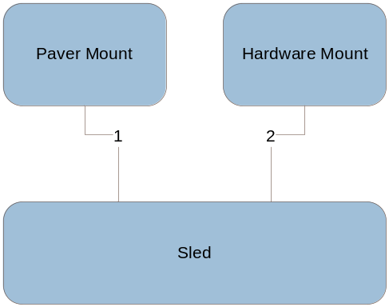
Figure 4 - Platform subsystems

Paver Mount
The paver mount is the mechanism by which the profiler will be physically attached to a standard road paver used by contractors. It aids in providing stability and ease of movement to the platform structure.

Hardware System Mount
The hardware system mount is the medium by which the electronics housing box will attach to the top side of the platform structure.

Sled
The sled portion of the profiler is the part of the product that glides across wet road surface. It provides a platform for which the profiler electronics and sensors can function and collect data.
Responsibilities:
- Translation of the inclination of the cement surface plane perpendicular to a vertical position
- Translation of the forward-progress of the plane in a direction that is parallel to that plane

Inter-subsystem Connections
Connection | Description
1 | Physical connection between the paver mount and the sled.
2 | Physical connection between the hardware mount and the sled.
Table 2 - Platform Subsystem Connections

Hardware System

General
The Hardware system is primarily responsible for providing all physical connectivity between the sensors and the Software system. It is also responsible for providing the Software system with a platform in which to operate on. In addition, it is responsible for all power distribution to all subsystems of the Sliding Profiler.

Subsystems
The Hardware system is comprised of the following subsystems:

- Electronics Housing
- Sensors
- Display
- Communication
- Processor
- Storage
- Cooling
- Power Distribution
- Client PC

Electronics Housing
The electronic housing is responsible for providing a secure mounting platform for all the sensors and circuitry. It is also responsible for protecting the electronics from the elements.

Sensors
- Inclinometer - The inclinometer is responsible for reacting to the angle of the platform and providing a voltage signal that the Software system will use for operational data.
- Distance Sensor - The distance sensor is responsible for translating the distance traveled into a voltage signal that Software system will use for operational data.
- Temperature Sensor - The temperature sensor is responsible for reading the temperature inside of the electronics housing and providing a voltage signal that the Software system will use for error checking.

Display
The display subsystem is responsible for providing the user with a visual indicator about the current state of the Sliding Profiler as well as alerts to detected bumps.

Communications
The communications subsystem is responsible for transmitting/receiving data to/from the client software. It is also responsible for communicating with the various hardware peripherals.

Processor
The processor subsystem is responsible for executing instructions from the Software system.

Storage
The storage subsystem is responsible for storing operational data on a non-volatile medium that will be read by the client software. It is also responsible for storing all calibration and configuration information for future use.

Cooling
The cooling subsystem is responsible for ventilating the electronics housing.

Power Distribution
The power distribution subsystem is responsible for providing the necessary and proper power to all subsystems requiring a separate power source.

Client PC
The client PC provides the operating system for the software subsystems intended for use by a technician. See the Software system for detailed information.

Inter-subsystem Dataflow
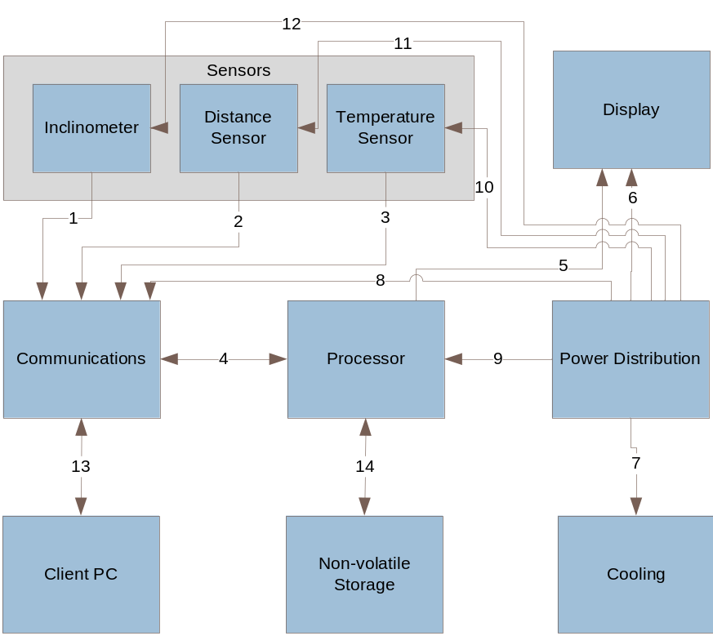
Figure 5 - Hardware Subsystems Dataflow

Connection | Description
1 | Physical connection between the inclinometer and the communications subsystem
2 | Physical connection between the distance sensor and the communications subsystem
3 | Physical connection between the temperature sensor and the communications subsystem
4 | Bi-directional interface between the processor and the communications subsystem
5 | Interface between the processor subsystem and the display subsystem
6 | Physical connection between the power distribution subsystem and the display subsystem
7 | Physical connection between the power distribution subsystem and the cooling subsystem
8 | Physical connection between the power distribution subsystem and the communications subsystem
9 | Physical connection between the power distribution subsystem and the processor subsystem
10 | Physical connection between the power distribution subsystem and the temperature sensor
11 | Physical connection between the power distribution subsystem and the distance sensor
12 | Physical connection between the power distribution subsystem and the inclinometer
13 | The connection between the Embedded device and the Client PC
14 | Physical connection between the processor and the storage device
Table 3- Connection Descriptions

Software System

General
The Software system is responsible for receiving and processing raw sensor data into operational events (i.e. bumps in the concrete surface) and displaying that information in various forms (i.e. text or graph to the technician through a GUI on a PC, or a sending a signal to a beacon light). It also provides an interface to any configuration process for the profiler algorithm and calibration process for the sensors.

Architectural Composition / Deployment
The Software system architecture can be decomposed into Layers and Subsystems as shown in below. The table also indicates how that subsystem may be deployed across the client PC and the embedded system.

Layers | Subsystems | Deployment
User Interface | GUI (Graphical User Interface) | Client PC
User Interface | Operational Display | Embedded System
PC IO Layer | Offline Data Storage Subsystem Delegate | Client PC/Embedded System
PC IO Layer | Data Acquisition Subsystem Delegate | Client PC/Embedded System
PC IO Layer | Profiler Subsystem Delegate | Client PC/Embedded System
PC IO Layer | Configuration Subsystem Delegate | Client PC/Embedded System
PC IO Layer | Calibration Subsystem Delegate | Client PC/Embedded System
Data Processing | Profiler Subsystem | Embedded System
Data Processing | Data Acquisition Subsystem | Embedded System
Storage Layer | Offline Data Storage Subsystem | Embedded System
Maintenance | Exception Handling | Embedded System
Maintenance | Configuration | Embedded System
Maintenance | Calibration | Embedded System
Table 4- Software Layers and Subsystem Deployment

Layers and Subsystems Definitions
This section describes the layers and subsystems of the Software system. Inter-subsystem dataflow will be described in a following section.

User Interface Layer
The User Interface layer is responsible for all interactions with the user. It is comprised of the GUI and Electronics Display subsystems.

GUI Subsystem
The GUI or Graphical User Interface subsystem provides the technician with an interface for viewing offline operational data, configuring the profiler and performing any necessary calibration tasks.
Deployment: Client PC
Assumptions:
- The client PC runs Windows operating system capable of supporting a Graphical User Interface developed with modern tools
Responsibilities:
- Reading and displaying operational data from the Offline Storage subsystem delegate
- Providing a means way to read and modify the configuration data through the Configuration subsystem delegate
- Enabling a technician to calibrate sensors as necessary through the Calibration subsystem delegate

Operational Display Subsystem
The Operational Display subsystem is responsible for indicating operational events such as bumps and error conditions. It also provides an indicator that the system is operating. Data for these are received from the Profiler and Exception Handling subsystems.
Deployment: Embedded device
Assumptions:
- The unit will be operated outside in bright light conditions
- Operators will be standing within 10’ - 20’ from the device
- Embedded device will provide an interface to raise a control signal in the Hardware display subsystem
Responsibilities:
- Providing Operational and Error Condition display to the operators

PC IO Layer
The PC IO layer is responsible for interfacing between the subsystems deployed on the client PC and those on the embedded device. Specifically, it provides a means of communication between the GUI subsystem, the Profiler, Data Acquisition, Configuration and Calibration subsystems.
It is comprised of the following subsystems:

Offline Data Storage Subsystem Delegate
The Offline Data Storage subsystem delegate handles communication between the subsystems on the client PC and the embedded device. It receives operational data from the Offline Data Storage subsystem and provides it to the GUI on request.
Deployment: Client PC
Assumptions:
- The client PC will provide the necessary file handling capabilities to IO with the hardware component of this subsystem
Responsibilities:
- Provide the GUI with a means of reading the operational data provided by the Offline Data Storage subsystem

Data Acquisition Subsystem Delegate
The Data Acquisition subsystem delegate handles communication between the GUI subsystems on the client PC and the embedded device. It receives operational data from the Offline Data Storage subsystem and provides it to the GUI on request.
Deployment: Client PC/Embedded device
Assumptions:
- The client PC provides the necessary low-level communication capabilities
Responsibilities:
- Provide the GUI with a means of reading the raw data provided by the Data Acquisition subsystem

Profiler Subsystem Delegate
The Profiler subsystem delegate handles communication between the subsystems on the client PC and the embedded device. It receives operational data from the Profiler subsystem and provides it to the GUI in real-time.
Deployment: Client PC
Assumptions:
- The client PC provides the necessary low-level communication capabilities
Responsibilities:
- Provide the GUI with a means of reading the operational data provided by the Profiler subsystem in real-time

Configuration Subsystem Delegate
The Configuration subsystem delegate handles communication between the subsystems on the client PC and the embedded device. It receives configuration data from the GUI and passes it to the Configuration subsystem deployed on the embedded device. It reads the configuration data from the Configuration subsystem on request.
Deployment: Client PC
Assumptions:
- The client PC provides the necessary low-level communication capabilities
Responsibilities:
- Provide the GUI deployed on the client PC with a means of communicating with the Configuration subsystem on the embedded device

Calibration Subsystem Delegate
The Calibration subsystem delegate handles communication between the subsystems on the client PC and the embedded device. It receives calibration commands from the GUI and sends that information to the Calibration subsystem deployed on the embedded device.
Deployment: Client PC
Assumptions:
- The client PC provides the necessary low-level communication capabilities
Responsibilities:
- Provide the GUI with a means of calibrating the profiler

Storage Layer
The Storage layer, deployed solely on the embedded device, provides for storing data while the embedded device is not connected to a client PC. The following subsystem is the sole component of this layer:

Offline Data Storage Subsystem
The Offline Data Storage subsystem receives operational data from the Profiler subsystem and stores it to non-volatile memory.
Deployment: Client PC
Assumptions: None
Responsibilities:
- Store operational data in non-volatile memory for transport to the client PC
- Store configuration data in non-volatile memory for use by the Profiler subsystem
- Store calibration data in non-volatile memory for use by the Data Acquisition subsystem

Data Processing Layer
The Data Processing layer is responsible for handling all data acquisition tasks from the Hardware layer, processes the data and generates the appropriate operational events. It handles storage of the data and makes it available to the UI layer. This layer is composed of the Profiler and Data Acquisition subsystems.

Profiler subsystem
The Profiler subsystem is responsible for analyzing the raw sensor data and determining if a bump has been detected.
Deployment: Embedded Device
Assumptions:
- The project sponsor’s algorithm is reliable and only needs translation to the new tool chain
- Translation of this algorithm will be the most time-consuming design and development component for the entire system
Responsibilities:
- Received raw sensor data from the Data Acquisition subsystem
- Analyze raw sensor data and determine if a bump has been detected
- Raise an alert to the Operational Display subsystem on the detection of a bump
- Signal that the system is operating through the Operational Display subsystem

Data Acquisition subsystem
The Data Acquisition subsystem is responsible for receiving raw sensor data and translating it to a usable format. It receives this sensor data from the individual sensor IO subsystems. The Data Acquisition subsystem also provides real-time raw data to the GUI by way of its subsystem delegate.
Deployment: Embedded Device
Assumptions:
- Raw data from sensors needs to be translated / decoded for use by the profiler

Responsibilities:
- Receive and translate raw sensor data into the necessary formats for the Profiler and Exception Handling subsystems

Maintenance Layer
The Maintenance layer actively monitors and handles exceptions, configures the profiler code and provides any necessary calibration services for the sensors. It is comprised of the Exception Handling, Configuration and Calibration subsystems.

Configuration subsystem
The Configuration subsystem handles requests from the GUI, by way of its delegate, with configuration data for the Profiler.
Deployment: Embedded Device
Assumptions:
- The profiler requires a lateral window size configuration value
Responsibilities:
- Accept and process configuration data from the GUI by way of the Configuration subsystem delegate
- Read configuration data and provide it to the GUI by way of the Configuration subsystem delegate

Calibration Subsystem
The Calibration subsystem handles requests from the GUI, by way of its delegate, for the Profiler.
Deployment: Embedded Device
Assumptions:
- The translation between the sensors and the profiler requires calibration
Responsibilities:
- Accept and process calibration requests from the GUI by way of the Calibration subsystem delegate

Exception Handling Subsystem
The Exception Handling subsystem monitors sensor data and other conditions for exceptions. It performs the necessary handling for these exceptions.
Deployment: Embedded Device
Assumptions: None
Responsibilities:
- Monitor for exceptions in the system and the data
- Appropriately handle all error conditions
- Raise alerts to the Operational Display subsystem as necessary
- Provide alert data to the profiler as necessary

Sensor IO Layer
The Sensor IO layer handles all communication from the inclinometer and the distance encoder sensors. It is responsible for decoding data from the device and providing data streams from each sensor to the data processing subsystem.

Inclinometer Sensor IO subsystem
The Inclinometer Sensor IO subsystem receives data from the physical device and provides it to the Data Acquisition subsystem.
Deployment: Embedded Device
Assumptions:
- Sensor devices provide a voltage input
Responsibilities:
- Accept raw sensor data and provide it to the Data Acquisition subsystem

Distance Encoder Sensor IO subsystem
The Distance Encoder Sensor IO subsystem receives data from the physical device and provides it to the Data Acquisition subsystem.
Deployment: Embedded Device
Assumptions:
- Sensor devices provide a voltage input
Responsibilities:
- Accept raw sensor data and provide it to the Data Acquisition subsystem

Temperature Sensor IO subsystem
The Temperature Sensor IO subsystem receives data from the physical device and provides it to the Data Acquisition subsystem.
Deployment: Embedded Device
Assumptions:
- Sensor devices provide a voltage input
Responsibilities:
- Accept raw sensor data and provide it to the Data Acquisition subsystem

Inter-subsystem Dataflow
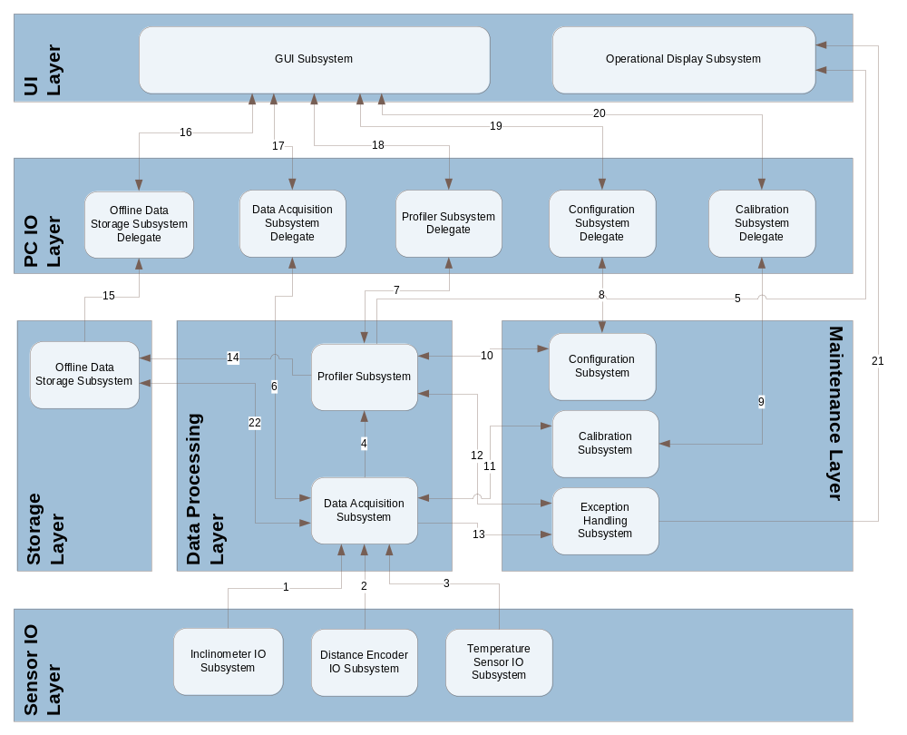
Figure 6 - Inter-subsystem Data Flow

Software System Connections
Connection | Description
1 | The Inclinometer IO Subsystem provides raw inclinometer data to the Data Acquisition Subsystem.
2 | The Distance Encoder IO Subsystem provides raw distance data to the Data Acquisition Subsystem.
3 | Temperature Sensor IO Subsystem provides raw temperature data to the Data Acquisition Subsystem.
4 | Data Acquisition Subsystem provides decoded data to the profiler subsystem.
5 | Profiler Subsystem provides heartbeat signal and bump alerts to the Operational Display Subsystem.
6 | Requests and raw data are exchanged between the Data Acquisition and its delegate subsystems.
7 | Requests and raw data are exchanged between the Profiler and its delegate system.
8 | Requests and raw data are exchanged between the Configuration and its delegate system.
9 | Requests and raw data is exchanged between the Calibration and its delegate system
10 | Configuration data is provided to and requested from the Profiler Subsystem
11 | Calibration data is provided to and requested from the Data Acquisition Subsystem by the Calibration Subsystem
12 | Exceptions are provided by the Profiler Subsystem to the Exception Handling Subsystem. Exception handling commands are provided by the Exception Handling Subsystem to the Profiler Subsystem
13 | Decoded sensor data (i.e. Inclinometer, Distance, Temperature) is provided by the Data Acquisition Subsystem to the Exception Handling Subsystem.
14 | Operational Events (i.e. bump detection events, exceptions) are provided by the Profiler Subsystem to the Offline Data Storage Subsystem. Configuration Data is exchanged between the Offline Data Storage by the Profiler subsystems.
15 | Operational Event data is provided by the Offline Data Storage Subsystem to its delegate.
16 | The Offline Data Storage Subsystem Delegate provides operational data to the GUI subsystem.
17 | The Data Acquisition subsystem Delegate provides raw data to the GUI subsystem
18 | The Profiler subsystem Delegate provides real-time operational data to the GUI subsystem.
19 | Commands and configuration data are exchanged between the GUI and the Configuration subsystem delegate
20 | Commands and calibration data are exchanged between the GUI and the Calibration subsystem Delegate
21 | System Exception Alerts are provided to the Operational Display subsystem
22 | Calibration data exchanged between the Data Acquisition and Offline Data Storage subsystems
Table 5 – Software Subsystem Connections

Producer/Consumer Relationships

Consumer Subsystem
Producer  Subsystem | GUI | Ops Display | Offline  Data  Storage  Delg | Data Acquisition  Delegate | Profiler  Delegate | Config  Delegate | Calibration  Delegate | Profiler | Offline Data Storage | Data Acquisition | Configure | Calibrate | Exception Handling | Incline  IO | Distance Sensor IO | Temp. Sensor IO
GUI |  |  | 16 | 17 | 18 | 19 | 20
Ops Display
Off. Data Sto. Delg | 16
Data Acq. Delg. | 17 |  |  |  |  |  |  |  |  | 6
Profiler Delg. | 18 |  |  |  |  |  |  | 7
Config Delegate | 19 |  |  |  |  |  |  |  |  |  | 8
Calibration Delegate | 20 |  |  |  |  |  |  |  |  |  |  | 9
Profiler |  | 5 |  |  | 7 |  |  |  | 14 |  | 10 | 11 | 12
Offline Data Storage |  |  | 15 |  |  |  |  | 14 |  |  |  | 22
Data Acquisition |  |  |  | 6 |  |  |  | 4 | 22 |  |  |  | 13
Configuration |  |  |  |  |  | 8 |  | 10
Calibration |  |  |  |  |  |  | 9 | 11
Exception Handling |  | 21 |  |  |  |  |  | 12
Inclinometer IO |  |  |  |  |  |  |  |  |  | 1
Distance Encoder |  |  |  |  |  |  |  |  |  | 2
Temperature Sensor IO |  |  |  |  |  |  |  |  |  | 3
Table 6 - Software Subsystem Producer/Consumer Relationships

Testing Considerations

General
Testing was a constant consideration in the development of this architecture. These considerations are not exhaustive and do not represent a test plan. Instead, they are things that the team believes the architecture leads them to understand about the testing needs of the product development process.
The architecture is modular along both functional and physical lines. Further, interconnectivity between systems and subsystems are clearly defined. Thus, this architectural definition lends to easy identification of areas that may need specific attention and segregates testing into several categories:

Physical / Structural
The device must operate in high temperatures in a construction environment where it may experience physical impact and stress. It also must meet certain requirements for being able to be cleaned. Example tests in this category include
- Testing the physical structure through stress and impact testing
- Testing the physical seals through moisture testing

System-level Connectivity Requirements
Selected components of each subsystem within a given system must meet the requirements placed upon it by its connectivity requirements with other systems.

Subsystem-level Interfaces
Subsystems can be treated as black-boxes to determine if each consumes data and produces the correct output. Some subsystems in the Hardware system may require non-software tests. For example, the Power Distribution subsystem should accept the 12 VDC power input and provide the necessary voltage for those subsystems that require power. The output voltage coming from this subsystem may be tested using a voltmeter.

